BARN CAT ADOPTION PROCESS

The applicant should have a barn or outside sheltered area that is located a safe distance from traffic. The new owner will also agree to feed the cats and provide appropriate vet care and yearly vaccinations. Barn cats usually will be adopted in pairs or groups so they will have each other for company.

A Cat Shack volunteer will deliver the cats in an extra large dog crate. The crate will be placed in the barn or shelter, and the cats will live in the crate for the first three weeks. This will allow the cats to become acclimated to their surroundings. At the end of the third week, the cats are released from the cage to begin their new lives.

There is no charge to adopt barn cats, but donations are very much appreciated. Donations enable us to help more cats that are desperately in need.

The Cat Shack is a non-profit, 501(c)3 organization designed to help find homes for cats in need and aid in the fight to end pet overpopulation. Over the years, it has grown to become a large group of devoted volunteers who offer monthly low cost spay/neuter/vaccinations for feral and domestic cats, foster care to over 100 cats and kittens while they await their forever homes, bottle feeding for abandoned infant kittens, medical care, and of course, tons of love and affection. Many cats come to us as strays, orphans and unfortunately, sometimes as unwanted pets. Prior to adoption, we neuter/spay all cats and kittens, bring all required vaccines up-to-date, and test for Feline Leukemia and Feline Immuno deficiency virus. All animals in The Cat Shack program are kept until they find homes.

The Cat Shack, Inc.
PO Box 950
Trexlertown PA 18087
Phone: 610-967-9097
E-mail: catshack@ptd.net
Website: www.thecatshack.com

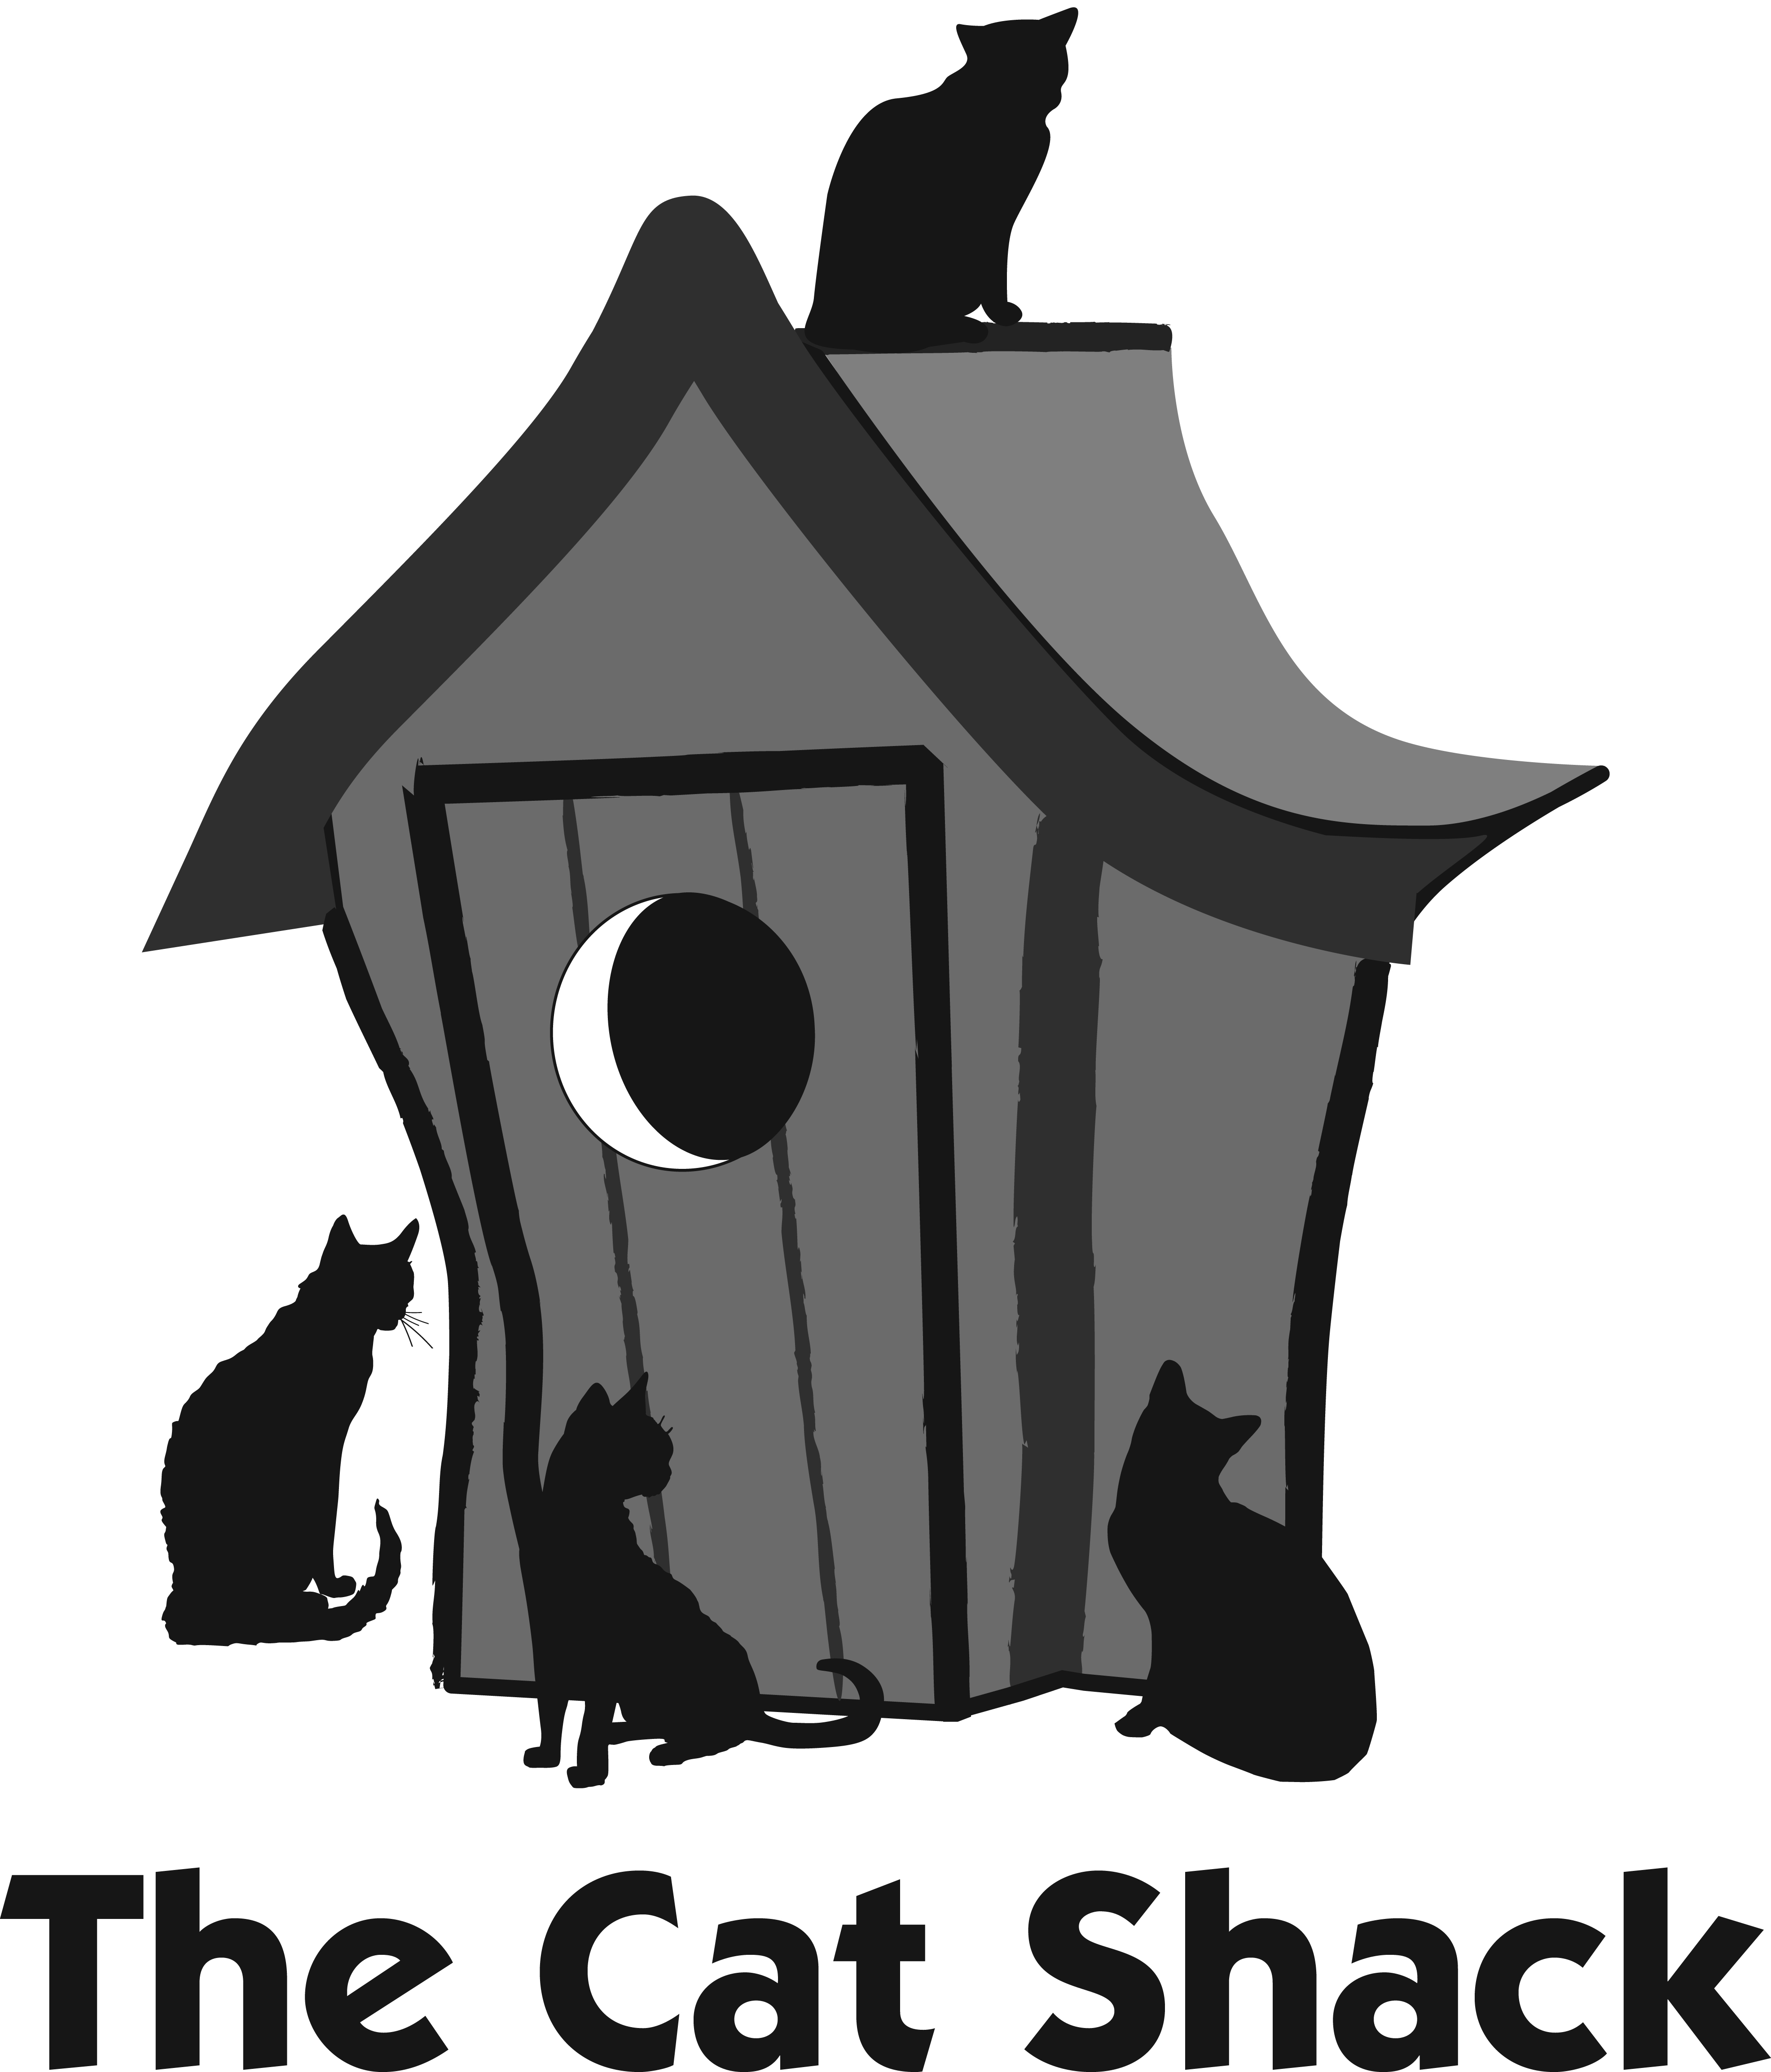

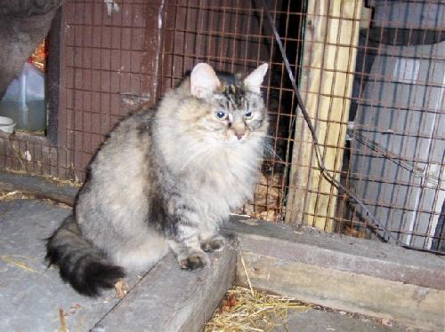

BARN CATS

WHAT ARE FERAL CATS?

The term “feral” means a previously domesticated animal that has reverted back to its wild state. Feral cats are often a result of people failing to spay/neuter their cats. Some are strays that have had to fend for themselves for a long period of time. Many others are the offspring of strays, and they have never been exposed to humans at an early age.

Feral cats live almost anywhere they can find food and shelter. They live around apartment complexes, construction sites, farms, abandoned buildings, and even the backyards of kind people who feed them. Unfortunately these feral cats do not usually make good house cats unless they are socialized indoors with humans before they are about six months old.

Even though we feel sorry for them, feral cats are actually happier living outside than being trapped indoors. Cat Shack volunteers can work with concerned people by providing help with humane traps, getting the cats spayed or neutered, and vaccinations. Injuries and other medical problems can be treated if necessary. When possible, the cats are released back where they were found to live out their lives in a familiar setting. We also have cats that can not be returned, so they will reside in foster homes until a suitable barn home can be found.

