The Cat Shack rescue is an all-volunteer organization, and the adopted cats are delivered to your home. Because we deliver the cats to you, we must restrict the adoptions of our highly adoptable cats to a 1-hour drive from the Allentown PA area. In certain situations, 'special-needs' cats, feral cats, and older cats will be adopted to homes at a greater distance then a 1 hour drive from Allentown PA.

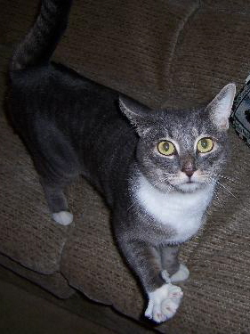
The Cat Shack is a non-profit, 501(c)3 organization designed to help find homes for cats in need and aid in the fight to end pet overpopulation. Over the years, it has grown to become a large group of devoted volunteers who offer monthly low cost spay/neuter/vaccinations for feral and domestic cats, foster care to over 100 cats and kittens while they await their forever homes, bottle feeding for abandoned infant kittens, medical care, and of course, tons of love and affection. Many cats come to us as strays, orphans and unfortunately, sometimes as unwanted pets. Prior to adoption, we neuter/spay all cats and kittens, bring all required vaccines up-to-date, and test for Feline Leukemia and Feline Immuno deficiency virus. All animals in The Cat Shack program are kept until they find homes.

The Cat Shack, Inc.
PO Box 950
Trexlertown PA 18087
Phone: 610-967-9097
E-mail: catshack@ptd.net
Website: www.thecatshack.com

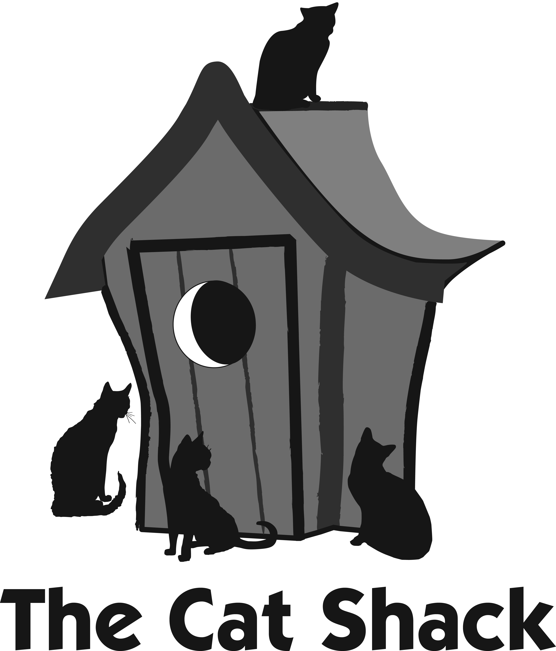

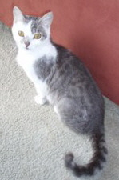

HOUSE CATS

ADOPTION INFORMATION
There is no fee or obligation to adopt at the time of application. If you choose to adopt a house cat, we request a $85 adoption donation to help defray our expenses. Barn cats may be adopted for free, with an approved application.
Applicants are asked to supply a vet reference, a personal reference and to list all current and former pets. Our goal is to match you with the right pet so you will both be happy for the remainder of your new pet's long and happy life. Remember: cats often live into their 20s and become very attached to their families. We have seen cats almost die from broken hearts when dumped at a shelter by their long-term caretakers.

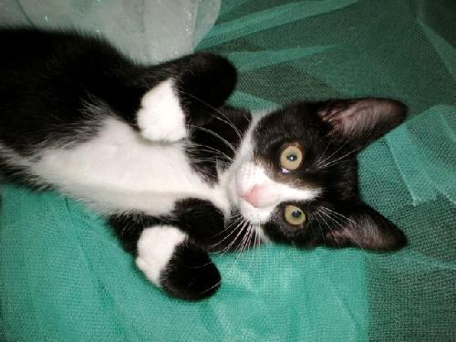
This $85 donation includes (Typical vet costs in our area):
- a FeLV/FIV test (a $35 value)
- Spay/Neuter for all cats and kittens (a $125-$150 value)
- Worming and flea treatment (a $16 value)
- All required vaccinations (a $16 value)
Clearly this adoption fee doesn't BEGIN to cover even the standard vet work our rescued cats receive. We appreciate any and all donations! This is what help keeps us in the business of helping strays.
A standard legal contract of adoption will be completed at the time of adoption. Any animal adopted from The Cat Shack that cannot be kept for any reason must be returned to the rescue.
The agreement includes a clause that you will not declaw a cat adopted from The Cat Shack. Declawing is a painful and unnecessary amputation of the first joint of the paw that can cause litter box problems and behavioral issues. Declawing has been banned in Europe where it is recognized as an act of cruelty. We would be happy to send you information explaining why we oppose this damaging procedure. If you wish to adopt an already declawed cat we have many waiting.
Our animals are housed in foster homes rather then a shelter. Visiting the cat and adoptions are by appointment only.

